Evidence Questions (1) on JavaScript

*IDB-BISEW IT Scholarship Project*

*Batch ID: WDPF/TCLD-A/47/01*

*Instructor Name: Syed Ziaul Habib*

1. Write an html document to take three marks entry from user (MCQ, Descriptive,

Evidence). If the marks of MCQ>=80, Descriptive>=60 and Evidence>=60 then give

a message “You have passed” otherwise give a message “You have failed”.

1. Using JavaScript stores five students information in an array and print the student names in sorted order.
2. Create an html form to take a date input and show the day/year of that date in the alert message.
3. Create an html form to take a string value and a search string value. Show an alert message that the search string is found in the input string or not. If found then show the index position also.
4. Create an html document with two buttons, open and close. Write JavaScript code to open a new window using open button and close the window using close button.

Evidence Questions(2) on JavaScript

*IDB-BISEW IT Scholarship Project*

*Batch ID: WDPF/TCLD-A/47/01*

*Instructor Name: Syed Ziaul Habib*

1. Create an html document to find Prime of a given number (n!) where the number is taken from user.

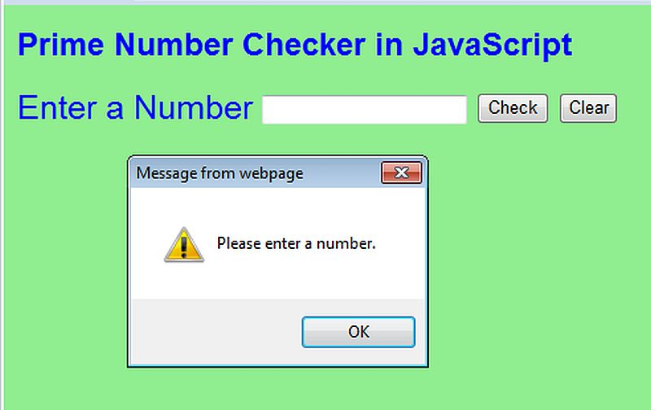

1. Create a login form and check the following validation using JavaScript:
2. Email address with valid structure.
3. Password is minimum 6 characters long.

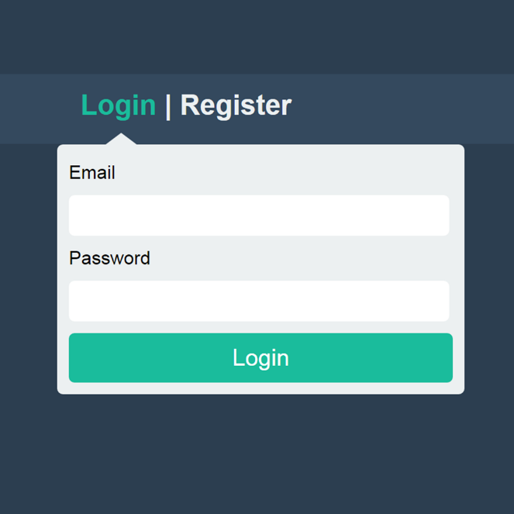

1. Create an html document with a student entry form. All fields are must be filled out. Apply JavaScript validation for each field. After validation preview them in a new window.

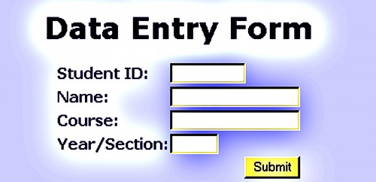

Evidence Questions (3) on JavaScript

*IDB-BISEW IT Scholarship Project*

*Batch ID: WDPF/TCLD-A/47/01*

*Instructor Name: Syed Ziaul Habib*

1. Create an online form to collect trainee’s data with the following fields:
   1. Input box for (i.) Name (ii) Contact
   2. Text Area for (i) Remarks
   3. Radio Buttons for (i) Sex (Male or Female identification)
   4. Checkbox for selecting Multiple Courses Like NT, IAD, DDD,ESAD etc
   5. Drop down List for selecting location Like, Banani, Dhanmondi, Mirpur etc.
   6. Button for submitting the form.

Write Script with required functions to show data in a formatted way in a new window when user click submit button filling the form.

1. Write a program which will test user email address. When the script executes, a prompt asks user to enter email address. If the script logic finds ‘**@** ‘and ‘**.’** symbols in email address that is entered then the output will be “Email Address is correct” otherwise “Email Address is Wrong”.

1. Find out prime number by JavaScript?

Evidence Questions (4) on JavaScript

*IDB-BISEW IT Scholarship Project*

*Batch ID: WDPF/TCLD-A/47/01*

*Instructor Name: Syed Ziaul Habib*

1. Create an html file named **billing.html** with the form below:

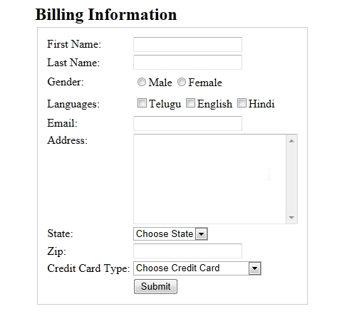

Write Script with required functions to show data in a formatted way in a new window when user click submit button filling the form.

1. Write an html document to find factorial of a given number (n!) where the number is taken from user. Save in a file named factorial.html

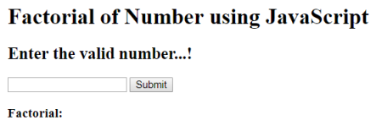

1. Find whether a number is prime or not. User will give the number. Save in a file named checkPrime.html



1. Using JavaScript stores five students name in an array. Make them all uppercase then print the student’s name in ordered list. Save in a file named studentList.html

Evidence Questions (5) on JavaScript

*IDB-BISEW IT Scholarship Project*

*Batch ID: WDPF/TCLD-A/47/01*

*Instructor Name: Syed Ziaul Habib*

1. Create an online form to collect trainee’s data with the following fields:
   1. Input box for (i.) Name (ii) Phone
   2. Text Area for (i) Address
   3. Radio Buttons for (i) Sex (Male or Female identification)
   4. Checkbox for selecting Multiple Courses Like NT, WDPF, DDD, Graphics etc
   5. Drop down List for selecting location Like, Uttara, Gandaria, Mirpur etc.
   6. Button for submitting the form.

Write Script with required functions to show data in a formatted way in a new window when user click submit button filling the form.

1. Write a program which will test user email address. When the script executes, a prompt asks user to enter email address. If the script logic finds ‘**@** ‘and ‘**.’** symbols in email address that is entered then the output will be “Email Address is correct” otherwise “Email Address is Wrong”.

1. Find out prime number by JavaScript?